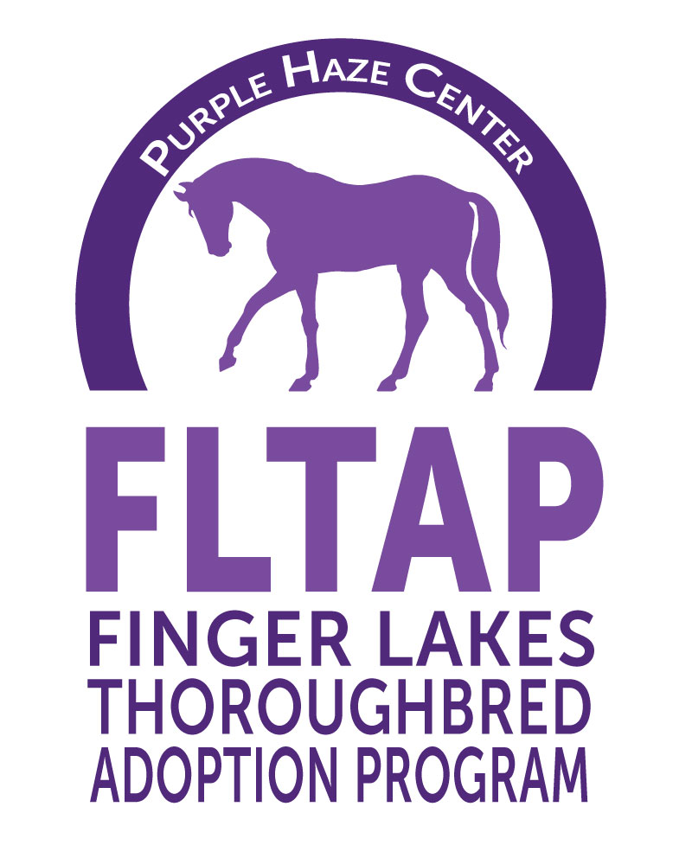

Sponsor Name: ____________________________________________________

Contact Name: ____________________________________________________

Address: ____________________________________________________

Phone: ____________________________________________________

Email: ____________________________________________________

Fax: ____________________________________________________

Sponsor Level
_______ $500 Will sponsor our horses bedding for one month
_______ $400. Will sponsor our horses with feed for one month
________$300. Will sponsor our horses with hay for one month
________$150. Sponsor a stall for one month. You will receive a picture, Jockey Club name and race record of the horse that is currently residing in that stall!

Attach a name or business card with a logo or artwork if you would like to be recognized for your sponsorship. Return to the address below or send in JPEG or PNG format (for best resolution) to fltapjulie@yahoo.com

Please mail form and check to:

FLTAP

P.O. Box 25043

Farmington, NY 14425

Attn: Julie Smith

** Checks payable to FLTAP. If you have any questions email us at fltapjulie@yahoo.com

Thank you for your support!!

5757 State Route 96, Farmington, NY 14425
P.O. Box 25043, Farmington, NY 14425 (585) 500-5333 fltapjulie@yahoo.com Tax Exempt# 16-1759140

